

**Lab 1: Using Git & Github**

Faculty of Engineering and Applied Science

SOFE 3650U: Software Project Management | CRN: 74667 | Section: 006 | Group: 10

Due: January 26th, 2023

Jordan Frost Hagedorn(100828122)

Ontario Tech University

Oshawa, Ontario

jordan.hagedorn@ontariotechu.net

Noah Toma (100825559)

Ontario Tech University

Oshawa, Ontario

noah.toma@ontariotechu.net

Dmitri Rios Nadeau (100783206)

Ontario Tech University

Oshawa, Ontario

ericdmitri.riosnadeau@ontariotechu.net

Github Repo: <https://github.com/D-aces/Software_Project_Management_Labs>

# Lab Deliverables

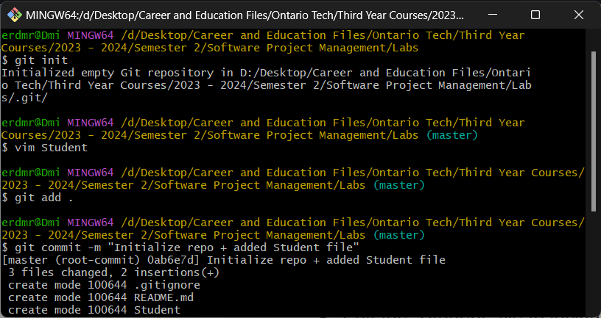

*Figure 1. Screen Capture of Local Git Repo Init., ‘Student’ file creation, & committing files*

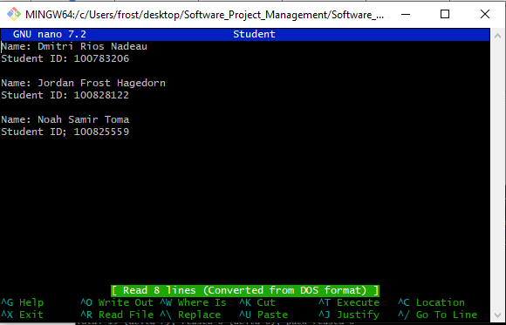

*Figure 2. Screenshot of ‘Student’ file contents*

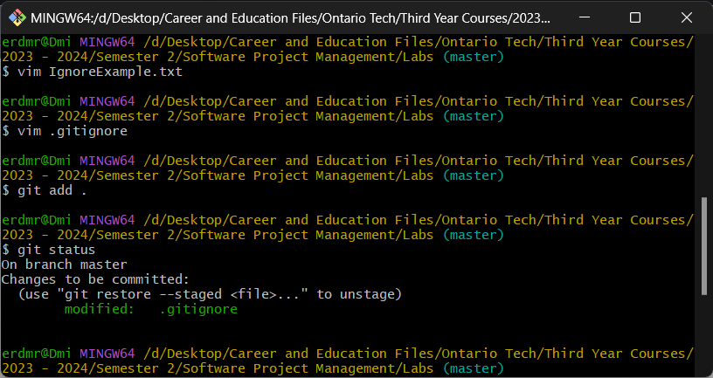

*Figure 3. Screen Capture of IgnoreExample.txt file creation + git status showing files to be committed*

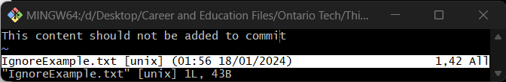

*Figure 4. Screen Capture of edited IgnoreExample.txt*

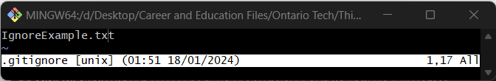

*Figure 5. Screen Capture of editing .gitignore file*

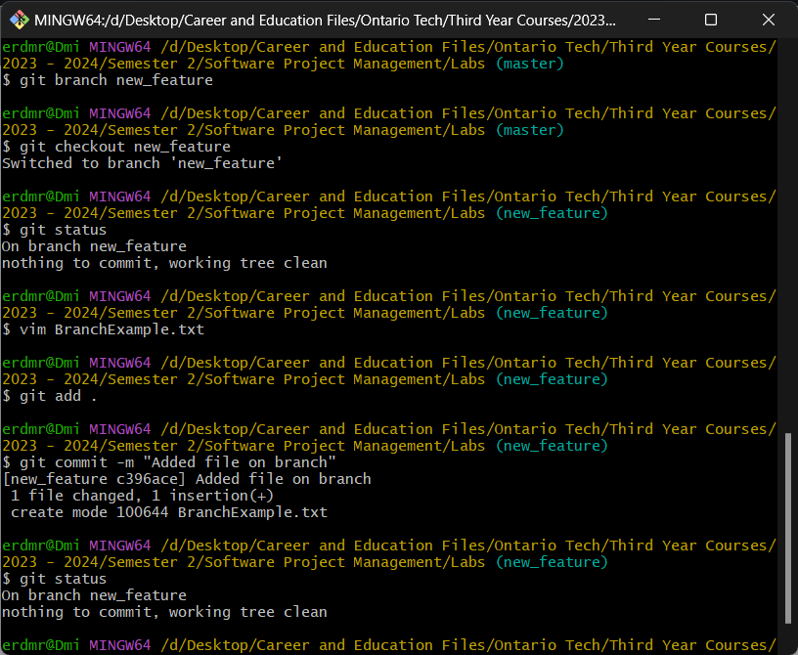

*Figure 6. Screen Capture of a new branch ‘new_feature’ being created, switching to ‘new_feature branch’, creation of ‘BranchExample.txt’, adding and committing ‘BranchExample.txt’ file to ‘new_feature’ branch*

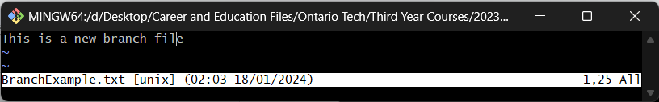

*Figure 7. Screen Capture of ‘BranchExample.txt’ file contents*

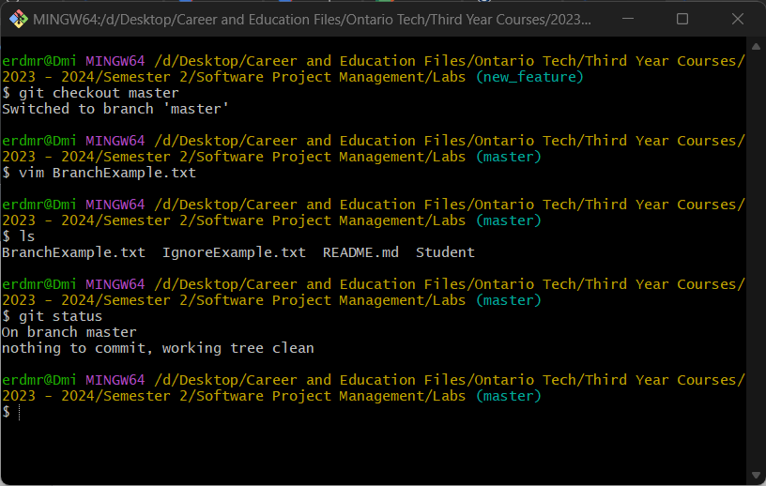

*Figure 8. Screen Capture of switch to ‘Master’ branch and creation of ‘BranchExample.txt’ in main branch*

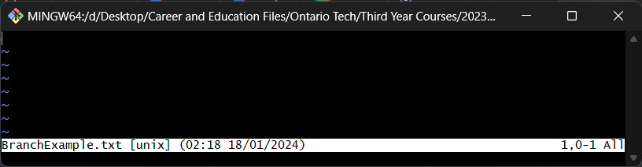

*Figure 9. Screen Capture of ‘BranchExample.txt’ file contents in ‘master’ branch*

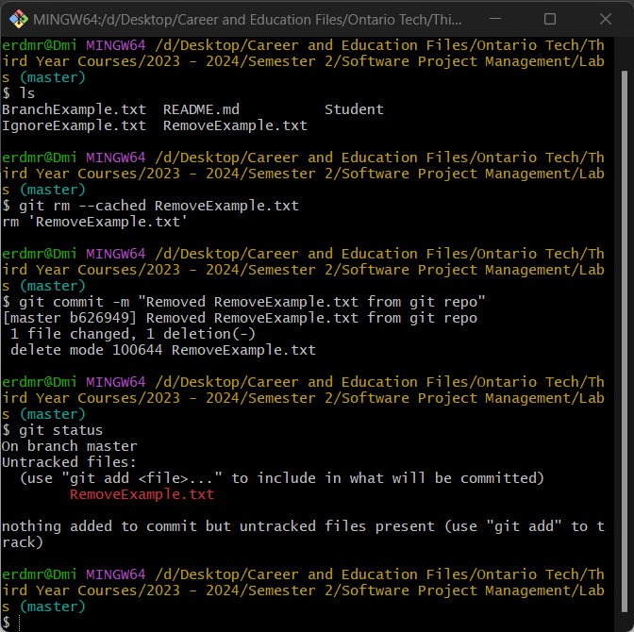

*Figure 10. Screen Capture of ‘RemoveExample.txt’ file removal, commit and status*

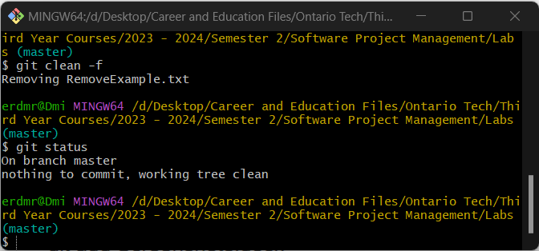

*Figure 11. Screen capture of clean and removal of ‘RemoveExample.txt’ file*

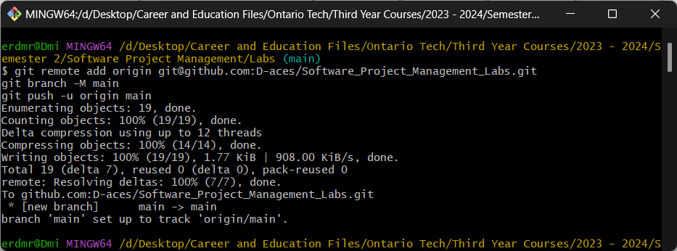

*Figure 12. Added files to a remote repository*